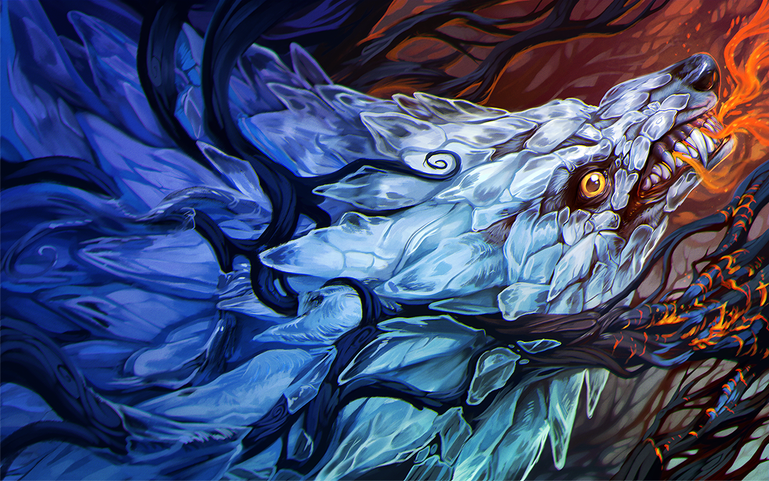

<http://www.deviantart.com/art/Break-the-Ice-665550864>

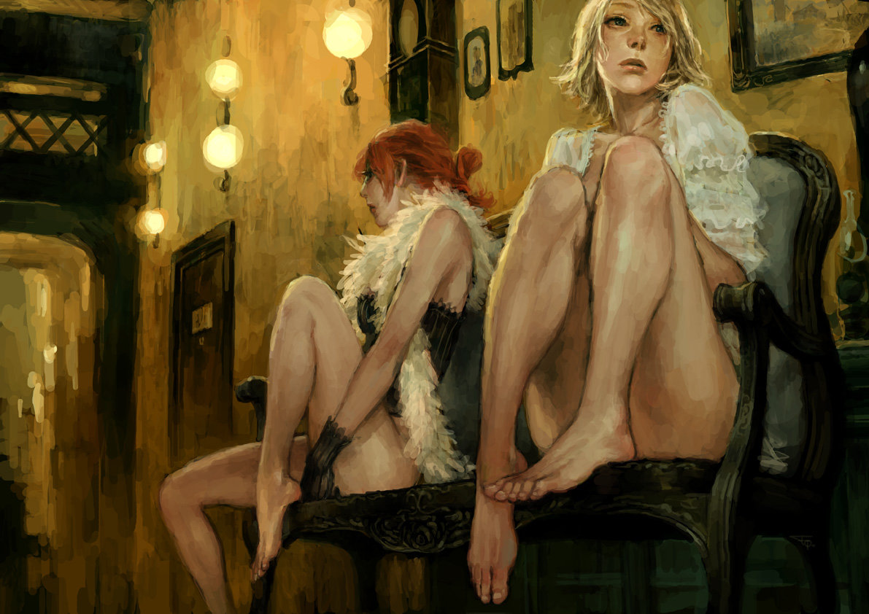

<http://www.deviantart.com/art/two-prostitutes-106774403>



<http://www.deviantart.com/art/Neurotic-Indisposition-71019219>



<http://www.deviantart.com/art/Impossible-LOV3-ver-3-35710689>

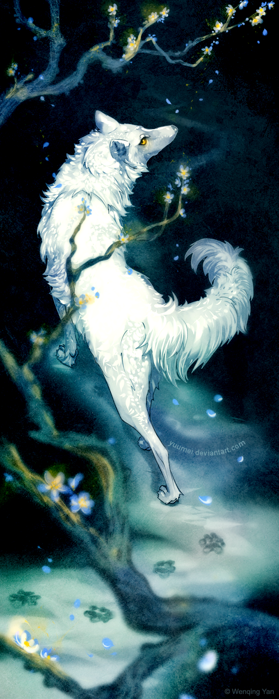

<http://www.deviantart.com/art/Wanderer-261521525>

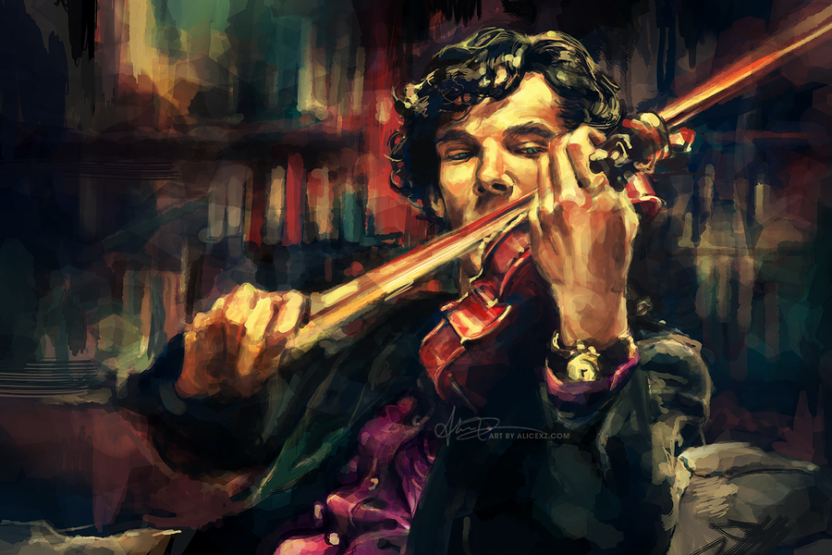

<http://www.deviantart.com/art/Virtuoso-256536410>

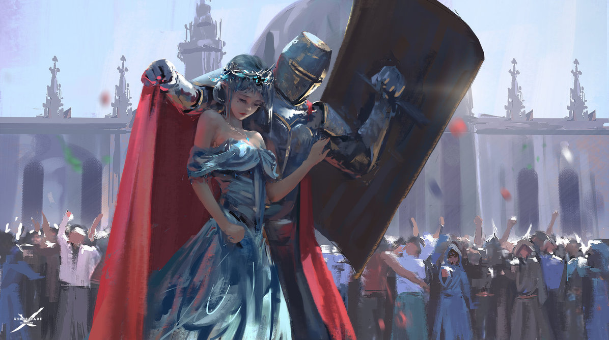

<http://www.deviantart.com/art/Guard-578845362>

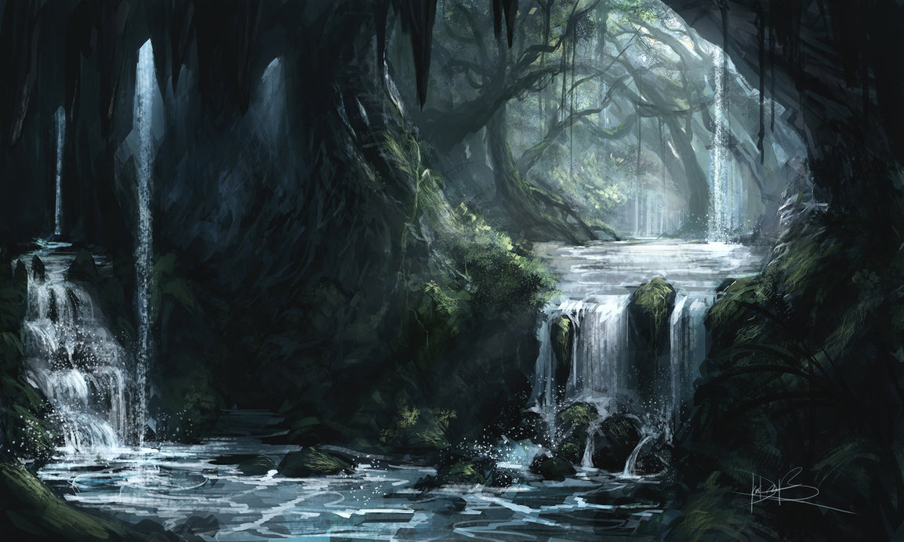

<http://www.deviantart.com/art/Cavern-383515969>

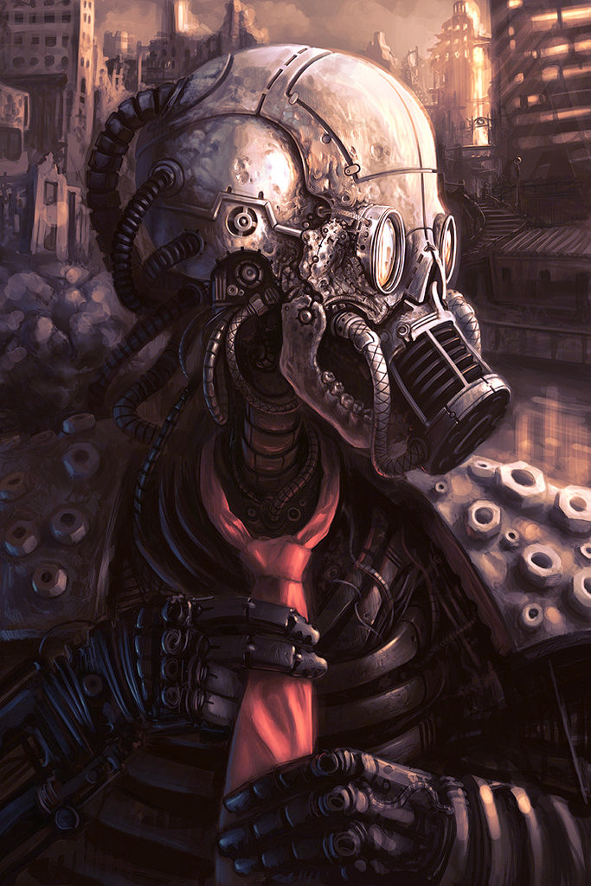

<http://www.deviantart.com/art/My-Red-Tie-3006638>

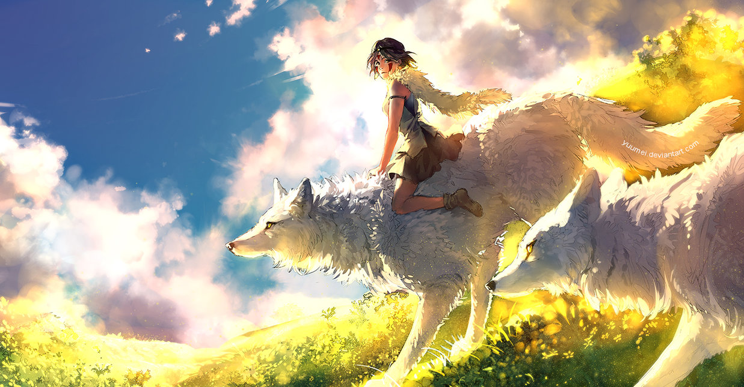

http://www.deviantart.com/art/Coexistence-460789698